**Dynamo db**

Step1:Login to aws console and search for IAM and open it and  go to iam and click on create user

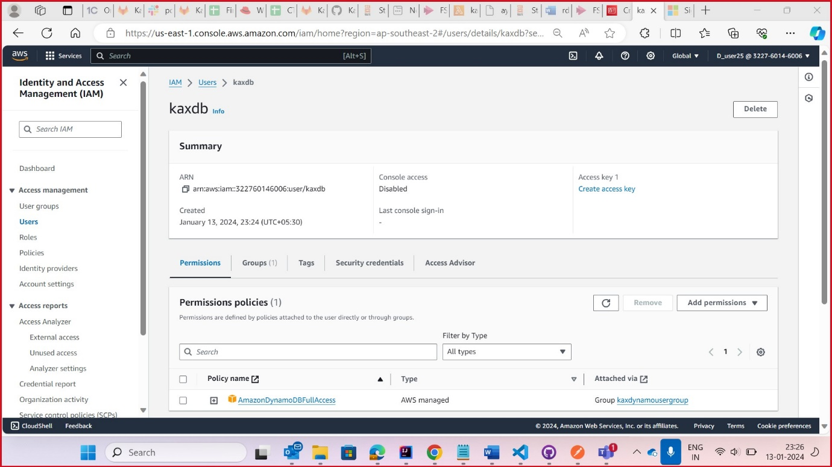

Step2:Click on user group and create one user group and give name for group

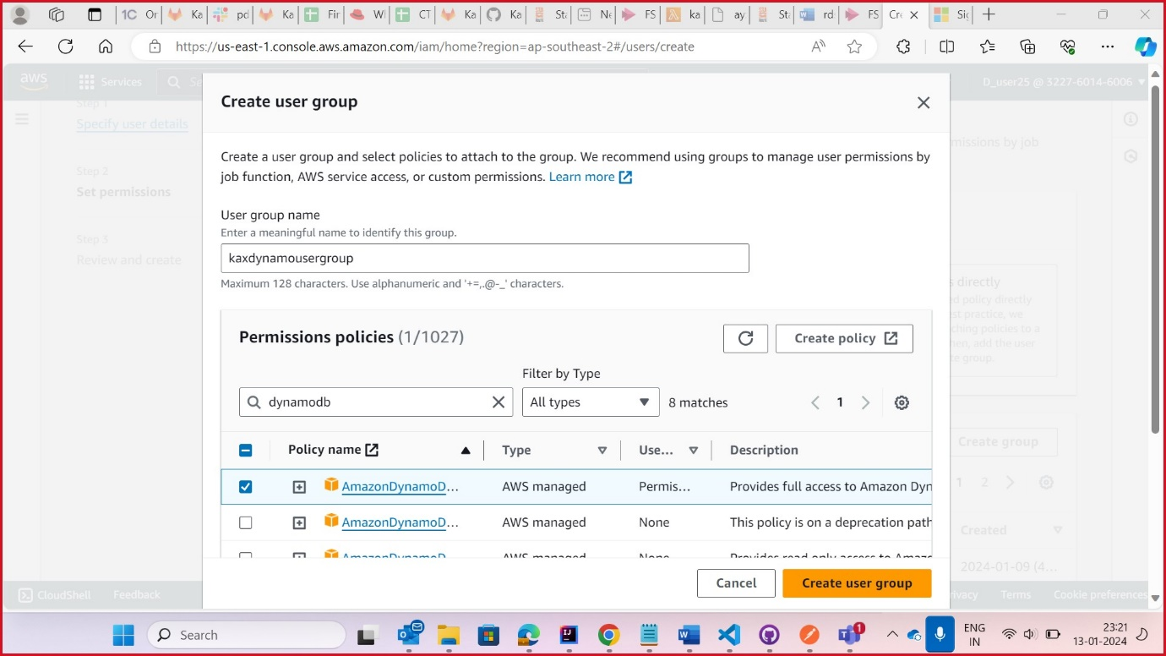

Step3: Click on user and create one user

Step4:After creating user create one access key for that user select local code and click next

Now click on create access key is generated

Step5:Open DynamoDB and create table

Step6:Give the table name and partition key and create table

Step7:create 1 Crud application and give the endpoint access key and secrete key and start the

Code

Step8:-check in postman

Step9:check in DynamoDB for our data is stored or not.